**Hands-on Lab 1: Create your AWS account**

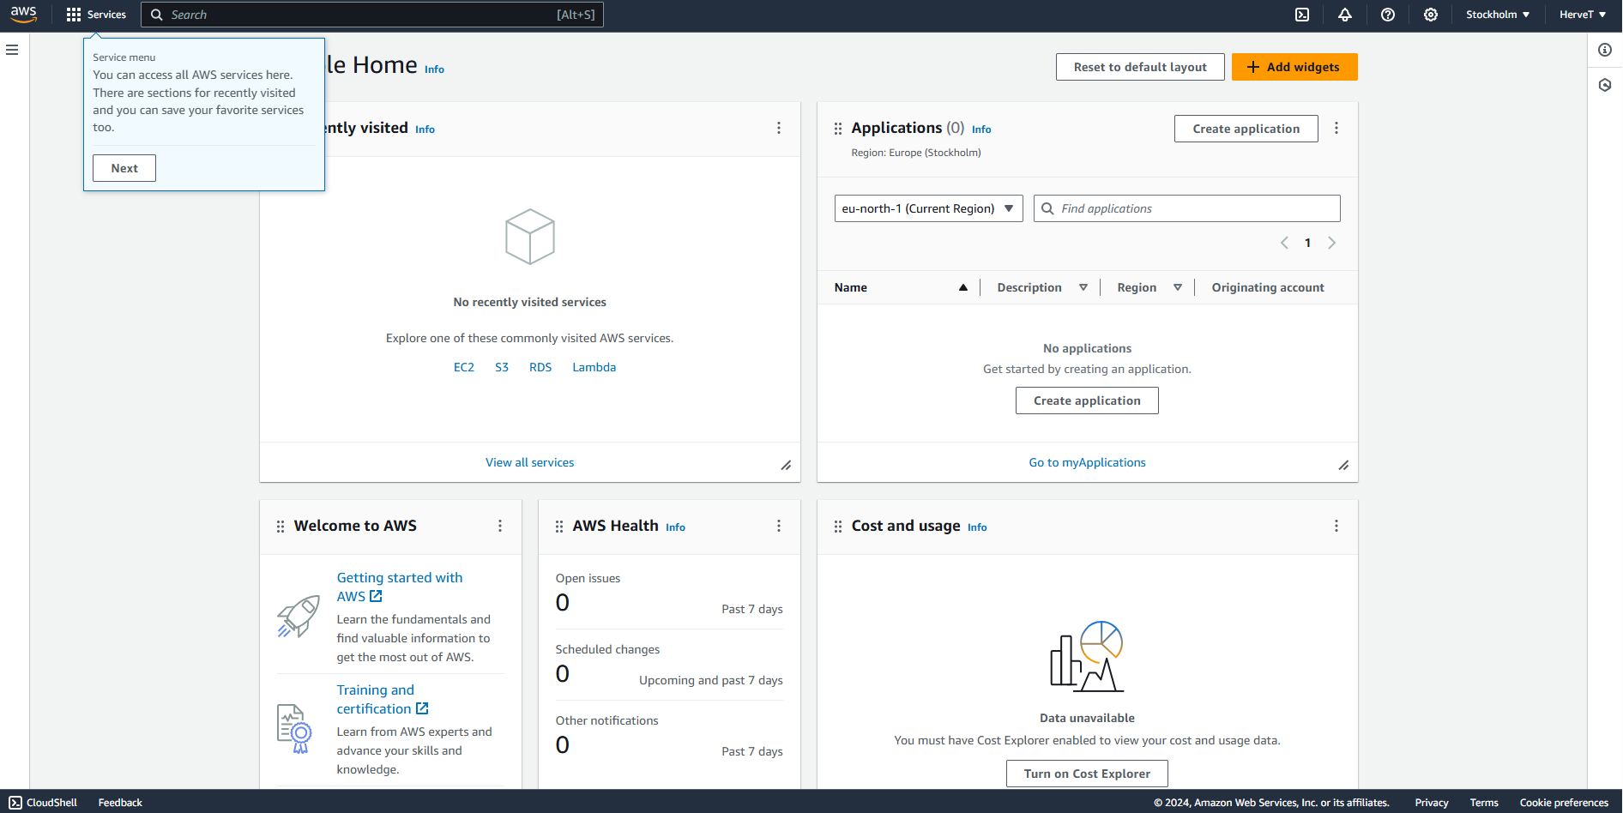

***Screenshot of my console home screen***